|  |  |  |  |
| --- | --- | --- | --- |
| STT | Câu hỏi | | Trả lời |
| 1 | Cấu trúc mục lục tài liệu của assignment gồm 3 phần lớn và trong các phần lớn có các mục nhỏ hơn do em tự làm hay copy? | | 100% |
|  | Trên thang điểm 10 em tự chấm điểm cấu trúc tài liệu được bao nhiêu điểm so với yêu cầu đề bài? | | 8.5/10 |
| **2** | | **Phần yêu cầu phần mềm gồm có functional requirements và non-functional requirement. Em tự chấm trên thang điểm 10 sẽ được bao nhiêu điểm so với yêu cầu đề bài?** | **7.5/10** |
| **3** | | **Những yêu cầu nào là yêu cầu phản ánh chính của hệ thống CRM phục vụ cho quản lý data ghi nhận gọi điện, email cho học sinh, phụ huynh học sinh? Input data do học sinh đưa vào hoặc cán bộ đưa vào hệ thống CRM rồi sau đó search, update như thế nào? Em tự chấm trên thang điểm 10 được mấy điểm so với yêu cầu của đề bài?** | **7.5/10** |
| **4** | | **Phần Architecture design cần phải vẽ các hình context diagram, deployement diagram, software packages, môi trường phát triển bao gồm phần cứng, phần frameworks đề làm phần mềm, giao thức. Qui tắc chia, hệ thống của em chia ra thành bao nhiêu project nhỏ để code thành project riêng trên IDE. Trao đổi data như thế nào giữa các app nhỏ, giữa các thành phần lớn của hệ thống? Hệ thống sắp xếp theo qui tắc nào hoặc mâu thiết kế nào(design pattern nào)? Em tự chấm phần này được mấy điểm trên thang điểm 10 so với yêu cầu đề bài?** | **7/10** |
| **5** | | **Deployment diagram sẽ mô tả hệ thống CRM của assignment này chạy cho 5 campus Hà Nội, TP HCM, Cần Thơ, Đà Nẵng, Qui Nhơn. Trên thang điểm 10 em tự chấm dc mấy điểm?** | **7/10** |
| **6** | | **Thiết kế architecture thường phải tuân theo các qui tắc thiết kế, em viết nội dung qui tắc và mô tả thiết kế của em thỏa mãn các qui tắc nào? Trên thang điểm 10 em tự chấm dc mấy điểm?** | **8.5/10** |
| **7** | | **Architecture thường để đạt mục tiêu non-functionals. Em mổ tả architecture của em đạt mục tiêu non-functional nào theo lý thuyết (vì chưa code, chưa test nên mới chỉ là lý thuyết thôi). Trên thang điểm 10 em tự chấm dc mấy điểm?** | **7.5/10** |
| **8** | | **Phần detail design phải có database table diagram và datadictionary phản ánh yêu cầu của hệ thống CRM quản lý data ghi nhận tương tác, input data của học sinh, của án bộ tuyển sinh. Em tự chấm điểm trên thang điểm 10 thì dc bao nhiêu điểm?** | **8/10** |
| **9** | | **Phần detail design sẽ vẽ 1 class diagram cho 1 feature. Em phải làm ít nhất 5 feature nên sẽ có ít nhất 5 class diagram. Em tự vẽ hay sử dụng lại? Em tự chấm trên thang điểm 10 thì dc bao nhiêu điểm?** | **9/10** |
| **10** | | **Phần detail design sẽ vẽ 1 sequence diagram cho 1 use case (1 use case sẽ là 1 hình elip trên use case diagram, tương ứng với 1 screen name). Sẽ phải làm ít nhất 35 use case. Trên thang điểm 10 em tự chấm được bao nhiêu điểm?** | **8/10** |
|  | |  |  |
|  | |  |  |

**Customer Relationship Management**

**To Support the Student Admissions**

**Software Design Document**

***

Subject: Software Architecture and Design

Lecturer: Nguyen Tat Trung

Class: SE1603KS

Student: Do Dinh Nam

Student ID: HE150684

- Hanoi, February 2023 -

Table of Contents

I. Software Requirements 6

1.1. Functional Requirements 6

1.1.1. System Use Cases 6

1.1.2. Use Case Diagram 8

1.1.3. Feature Tree 9

1.1.4. Screen Flow 10

1.2. Non-Functional Requirements 10

II. Software Architecture Design 12

2.1. Context Diagram 12

2.2. Component Diagram 13

2.3. Deployment Diagram 14

2.4. Source Code Structure 15

2.5. Development environment 16

2.6. Database 17

2.6.1. Database Table Diagram 17

2.6.2. Data Definition 18

III. Software Detail Design 21

3.1. Common 21

3.1.1. Class Diagram 21

3.1.3. Screen Design 21

3.1.4. Sequence Diagram 25

3.2. Account Management 27

3.2.1. Class Diagram 27

3.2.3. Screen Design 28

3.2.4. Sequence Diagram 31

3.3. Admission Management 34

3.3.1. Class Diagram 34

3.3.3. Screen Design 35

3.3.4. Sequence Diagram 39

3.4. Examination 41

3.4.1. Class Diagram 41

3.4.3. Screen Design 42

3.4.4. Sequence Diagram 44

3.5. Marketing 45

3.5.1. Class Diagram 45

3.5.3. Screen Design 46

3.5.4. Sequence Diagram 49

3.6. Admin Management 50

3.6.1. Class Diagram 50

3.6.3. Screen Design 51

3.6.4. Sequence Diagram 53

# I. Software Requirements

## 1.1. Functional Requirements

### 1.1.1. System Use Cases

|  |  |
| --- | --- |
| **Primary actor** | **Use cases** |
| Guest | 1. View homepage 2. Register account 3. View university’s information 4. View academic programs 5. View campus maps 6. View housing information 7. View admission information |
| User | 1. Login 2. Log out 3. View profile 4. Edit profile 5. Change password 6. Setting 7. View notifications 8. Forget password |
| Prospective student | 1. Sign up for consultation 2. Apply for admission 3. Apply for financial aid 4. Apply for scholarship 5. Track application 6. Register asessment test 7. View assessment test information 8. View assessment test result 9. Contact admission counselor 10. Pay enrollment 11. View campus news and events 12. View extracurricular activity |
| Admissions staff | 1. Manage applications 2. Evaluate applications 3. Contact with applicants 4. Generate offer letters 5. Process deposits 6. Manage admission events 7. Generate admission reports 8. Manage admission policies and procedures |
| Exam officer | 1. Manage exam schedule 2. Monitor exam results 3. Manage exam logistics 4. Report exam performance |
| Marketing staff | 1. Develop campaigns 2. Segment prospective students 3. Track campaign 4. Coordinate events 5. Manage social media 6. Generate marketing reports 7. Manage partnerships |
| System administrator | 1. Manage user account 2. Monitor system performance 3. Manage integrations 4. Manage upgrades and updates |

### 1.1.2. Use Case Diagram

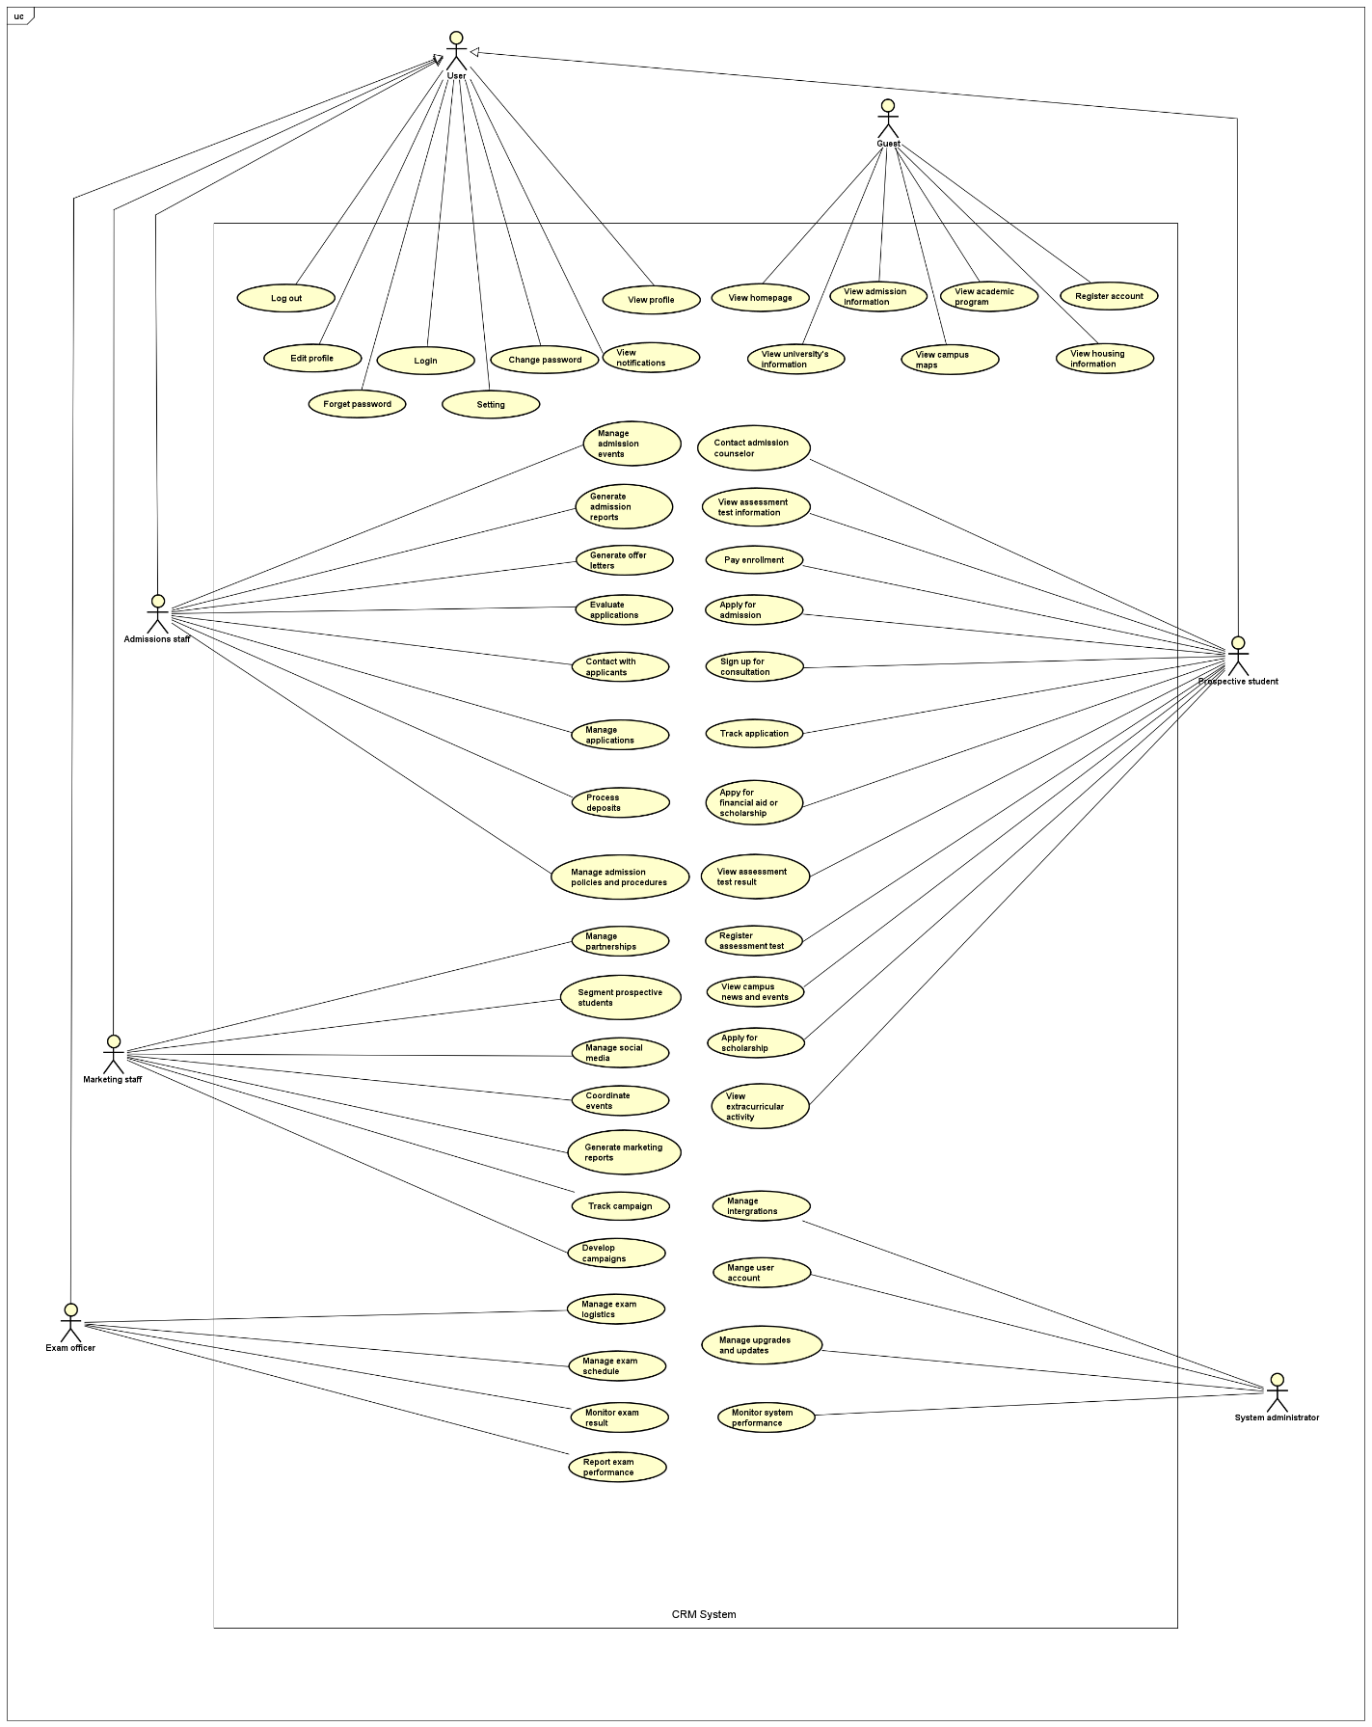

*Figure 1. Use case diagram.*

### 1.1.3. Feature Tree

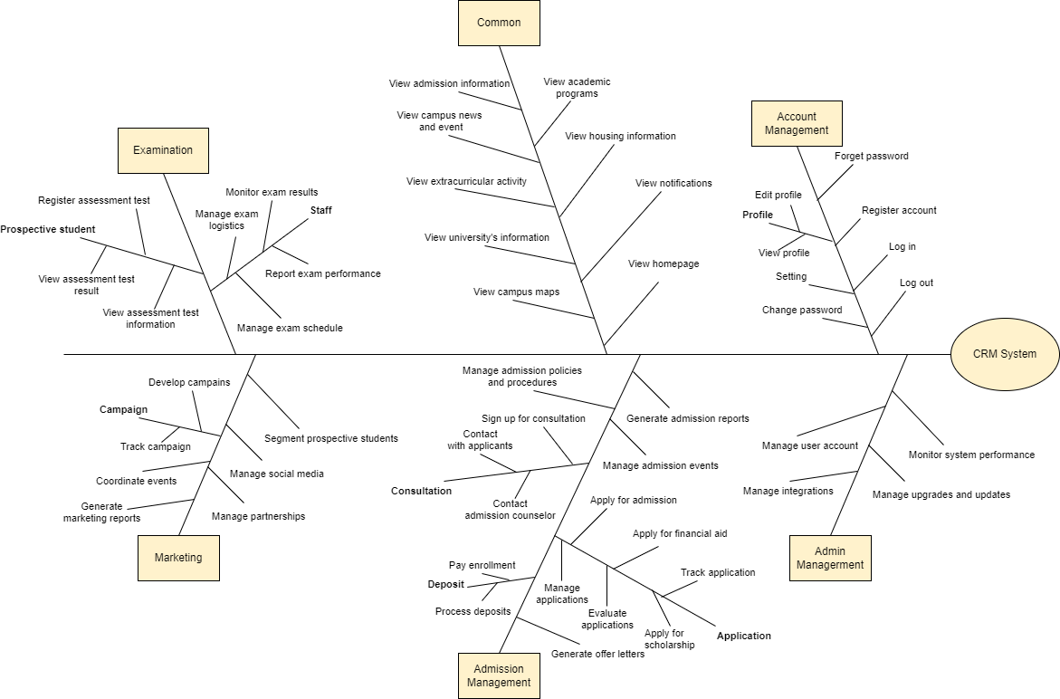

*Figure 2. Feature tree.*

### 1.1.4. Screen Flow

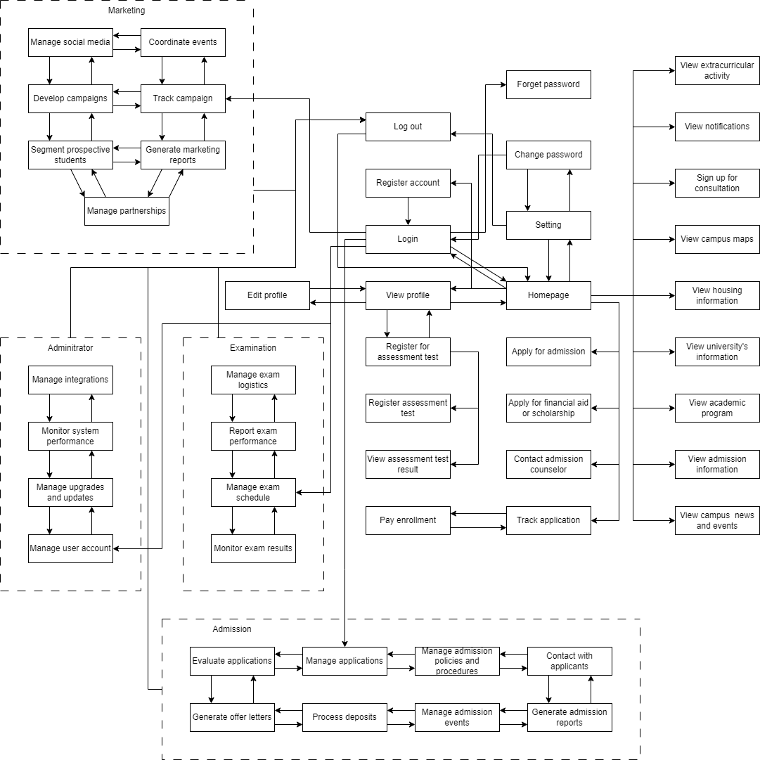

*Figure 3. Screen flow.*

## 1.2. Non-Functional Requirements

- **Usability:**

USA-1. The staff within 1 day training can easily use the system.

- **Performance:**

PER-1. The system should be responsive and loading times less than 2 seconds.

PER-2. The system can allow 10000 users access at the same time.

- **Scalability:**

SCA-1. The system should be able to manage up to 100000 users and data and be easily expandable to 500000 users in the future.

- **Security:**

SEC-1. The system should be secure and protect user data from unauthorized access or disclosure.

- **Compatibility:**

COM-1. The system should be compatible with computer, phone, tablet.

COM-2. The system should be compatible with both Windows and MacOS operating system on computer.

COM-3. The system should be compatible with browsers such as Google Chrome, Microsoft Edge, Opera, Brave, Firefox.

COM-4. The system should be compatible with both Android and IOS operating system on phone and tablet.

- **Maintainability:**

MAI-1. The maintain or update time have to maximum is 30 minutes downtime and disruption to users.

# II. Software Architecture Design

## 2.1. Context Diagram

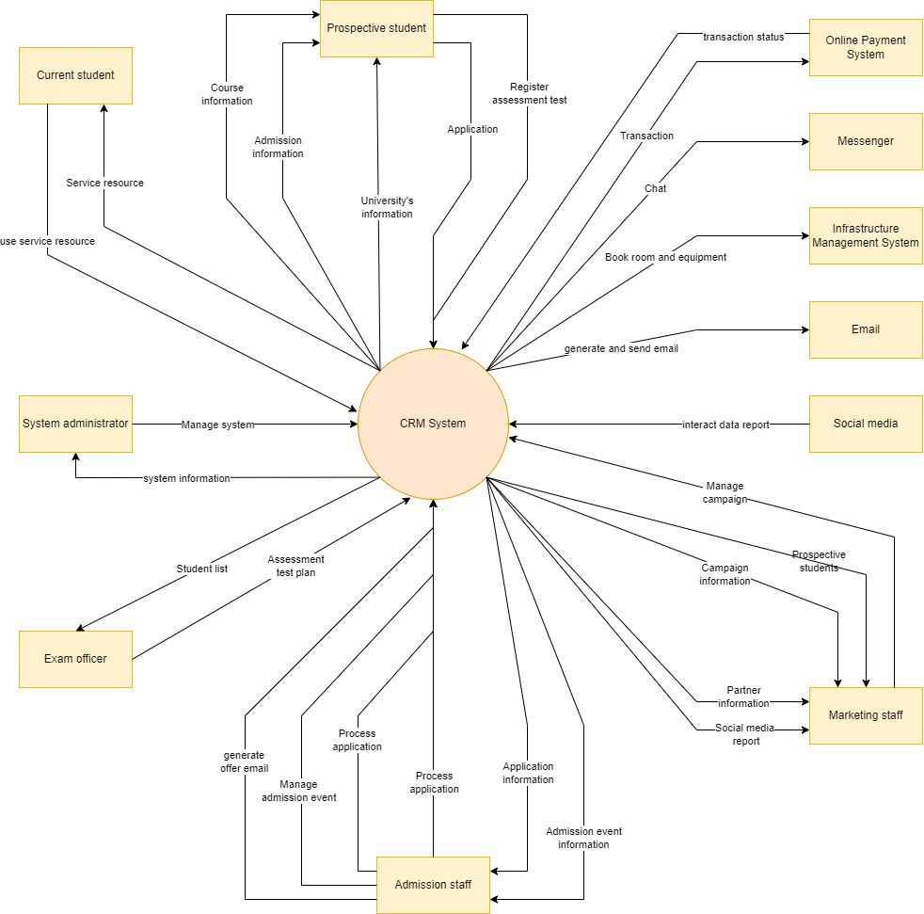

*Figure 4. Context diagram.*

## 2.2. Component Diagram

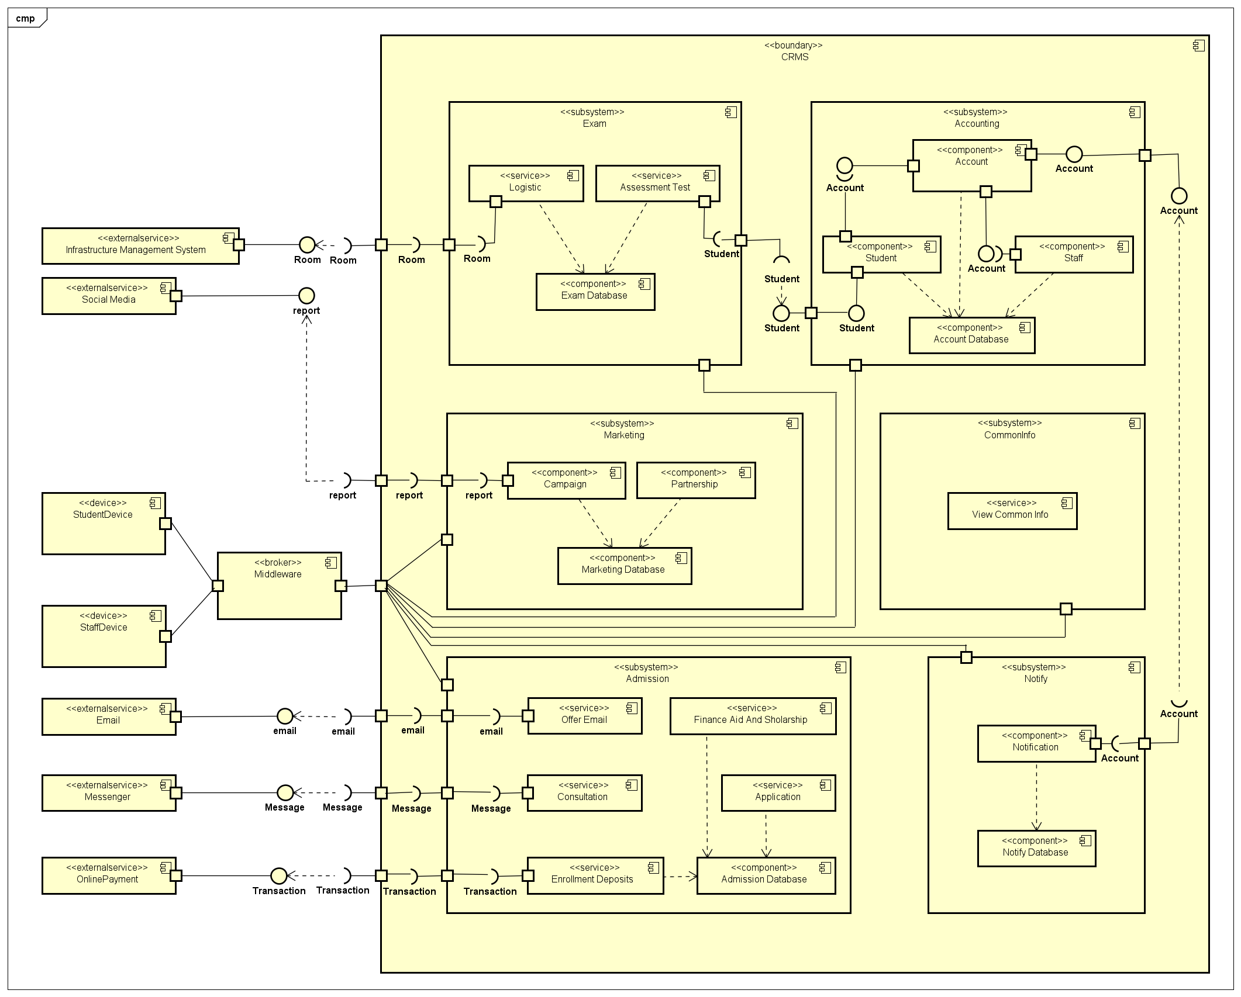

Figure 5. Component diagram.

## 2.3. Deployment Diagram

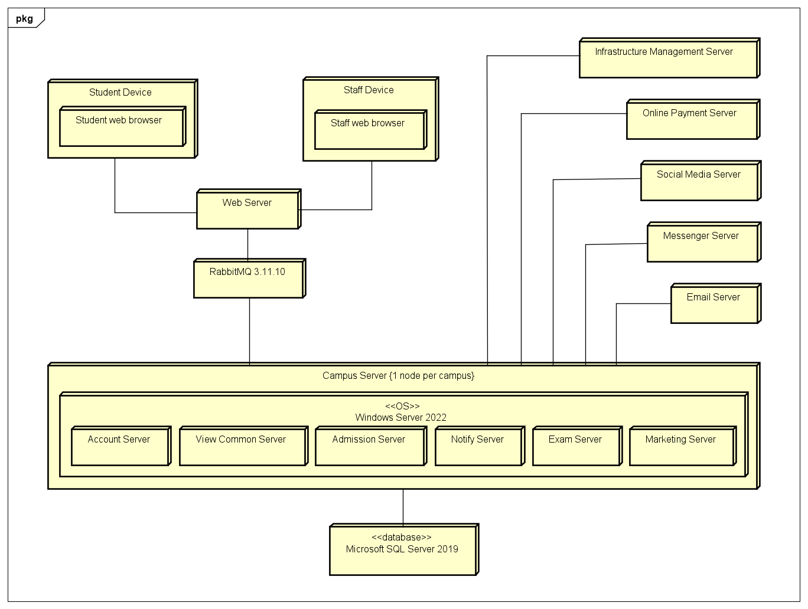

*Figure 6. Deployment diagram.*

## 2.4. Source Code Structure

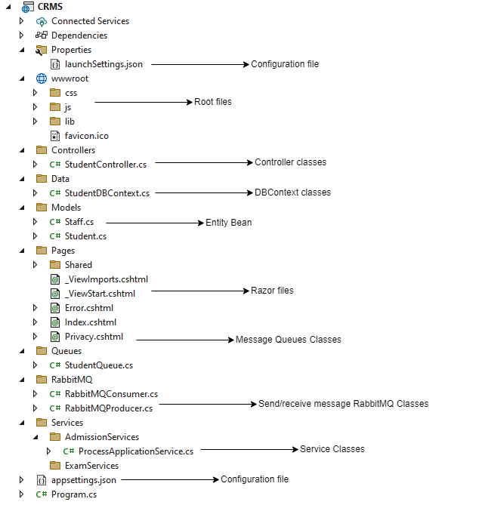

*Figure 7. Source code structure.*

## 2.5. Development environment

**Hardware**

|  |  |  |  |  |
| --- | --- | --- | --- | --- |
| **Device** | **OS** | **CPU** | **RAM** | **Storage** |
| Laptop MSI Prestige 14 | Windows 11 22H2 | Intel core i5 – 8250u | 8 GB | 256 GB |
| Samsung Galaxy S8 plus | Android 10 | Exynos 8895 | 6 GB | 128 GB |

**Software**

|  |  |
| --- | --- |
| **Software** | **Version** |
| Visual Studio | 2022 |
| Microsoft SQL Server | 2019 |
| RabbitMQ | 3.11.10 |

**Framework**

|  |  |
| --- | --- |
| **Framework** | **Version** |
| ASP.NET Core | 6.0 |

## 2.6. Database

### 2.6.1. Database Table Diagram

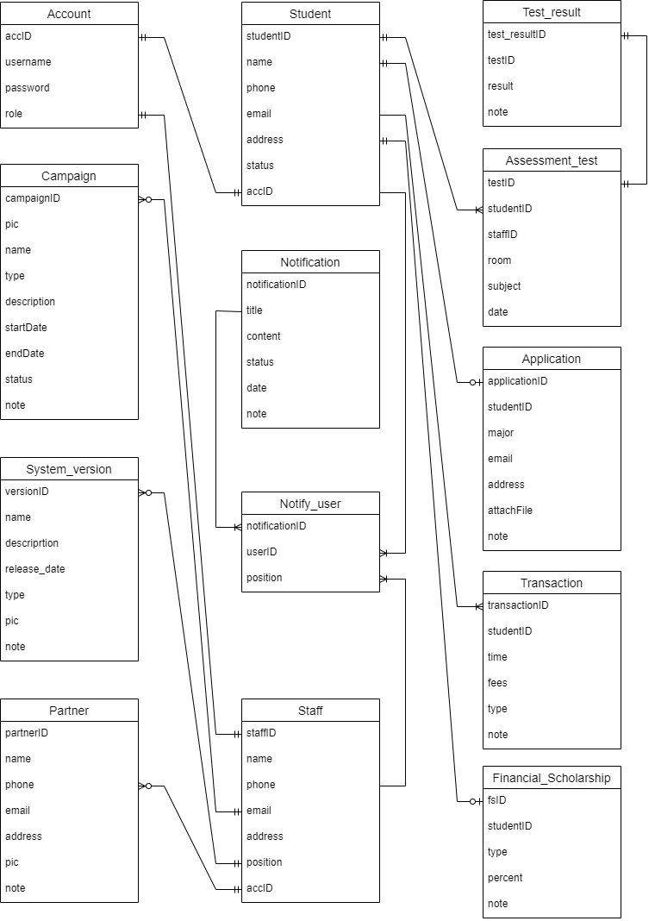

*Figure 7. Entity relationship diagram.*

### 2.6.2. Data Definition

**Account**

|  |  |  |
| --- | --- | --- |
| **Field name** | **Type** | **Description** |
| accID | int | PK |
| username | varchar(50) |  |
| password | varchar(50) |  |
| role | int |  |

**Student**

|  |  |  |
| --- | --- | --- |
| **Field name** | **Type** | **Description** |
| studentID | int | PK |
| name | varchar(50) |  |
| phone | varchar(10) |  |
| mail | varchar(100) |  |
| address | varchar(255) |  |
| status | bit |  |
| accID | int | FK |

**Staff**

|  |  |  |
| --- | --- | --- |
| **Field name** | **Type** | **Description** |
| staffID | int | PK |
| name | varchar(50) |  |
| phone | varchar(10) |  |
| mail | varchar(100) |  |
| address | varchar(255) |  |
| position | int |  |
| accID | int | FK |

**Assignment_test**

|  |  |  |
| --- | --- | --- |
| **Field name** | **Type** | **Description** |
| testID | int | PK |
| studentID | int | FK |
| staffID | int | FK |
| room | varchar(5) |  |
| subject | String |  |
| date | date |  |

**Test_result**

|  |  |  |
| --- | --- | --- |
| **Field name** | **Type** | **Description** |
| test_resultID | int | PK |
| testID | int | FK |
| result | int |  |
| note | int |  |

**Campaign**

|  |  |  |
| --- | --- | --- |
| **Field name** | **Type** | **Description** |
| campaignID | int | PK |
| pic | int | FK |
| name | varchar(100) |  |
| type | varchar(50) |  |
| description | varchar(255) |  |
| startDate | date |  |
| endDate | date |  |
| status | bit |  |
| note | varchar(255) |  |

**Notification**

|  |  |  |
| --- | --- | --- |
| **Field name** | **Type** | **Description** |
| notificationID | int | PK |
| title | varchar(100) |  |
| content | varchar(255) |  |
| status | bit |  |
| date | date |  |
| note | varchar(255) |  |

**Application**

|  |  |  |
| --- | --- | --- |
| **Field name** | **Type** | **Description** |
| applicationID | int | PK |
| studentID | int | FK |
| major | String |  |
| email | varchar(100) |  |
| address | varchar(255) |  |
| attachFile | varchar(255) |  |
| note | varchar(255) |  |

**System_version**

|  |  |  |
| --- | --- | --- |
| **Field name** | **Type** | **Description** |
| versionID | int | PK |
| name | varchar(100) |  |
| description | varchar(255) |  |
| release_date | date |  |
| type | int |  |
| pic | int | FK |
| note | varchar(255) |  |

**Notify_user**

|  |  |  |
| --- | --- | --- |
| **Field name** | **Type** | **Description** |
| notificationID | int | FK, PK |
| userID | int | FK, PK |
| position | int |  |

**Transaction**

|  |  |  |
| --- | --- | --- |
| **Field name** | **Type** | **Description** |
| transactionID | int | PK |
| studentID | int | FK |
| time | dateTime |  |
| fees | money |  |
| type | varchar(50) |  |
| note | varchar(255) |  |

**Partner**

|  |  |  |
| --- | --- | --- |
| **Field name** | **Type** | **Description** |
| partnerID | int | PK |
| name | varchar(100) |  |
| phone | varchar(10) |  |
| email | varchar(100) |  |
| address | varchar(255) |  |
| pic | int | FK |
| note | varchar(255) |  |

**Financial_Scholarship**

|  |  |  |
| --- | --- | --- |
| **Field name** | **Type** | **Description** |
| fsID | int | PK |
| studentID | Int | FK |
| type | bit |  |
| percent | int |  |
| note | varchar(255) |  |

# III. Software Detail Design

## 3.1. Common

### 3.1.1. Class Diagram

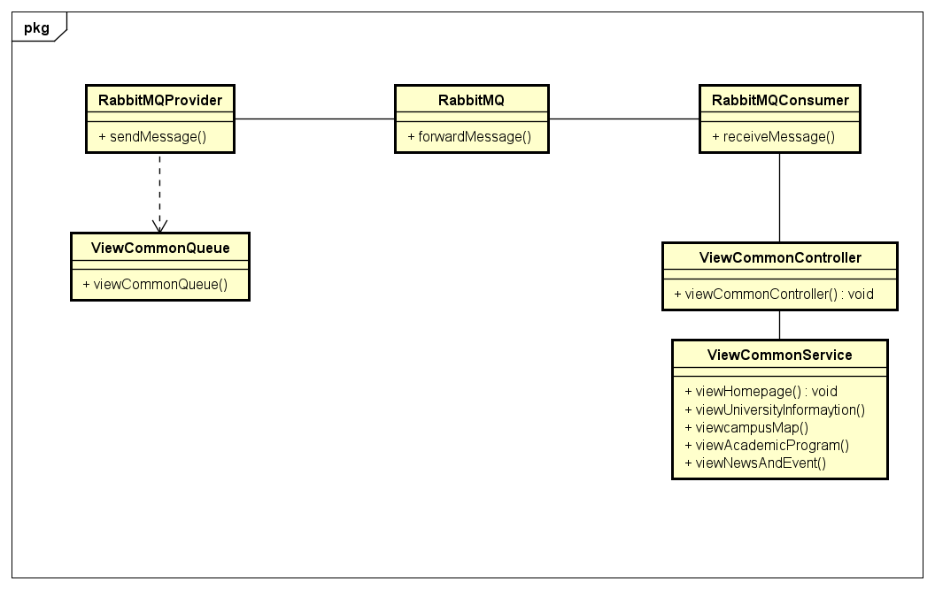

Figure 8. Common feature class diagram.

### 3.1.3. Screen Design

Figure 9. View Homepage screen design

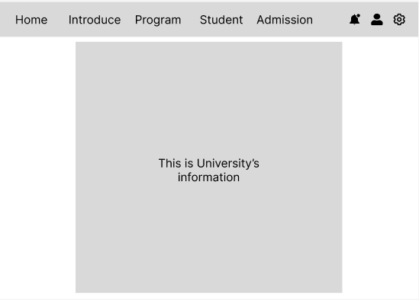

Figure 10. View University Information screen design

Figure 11. View Major Information screen design

Figure 12. View Campus Map screen design

Figure 13. View Housing Information screen design

Figure 14. View Admission Information screen design

Figure 15. View Notification screen design

### 3.1.4. Sequence Diagram

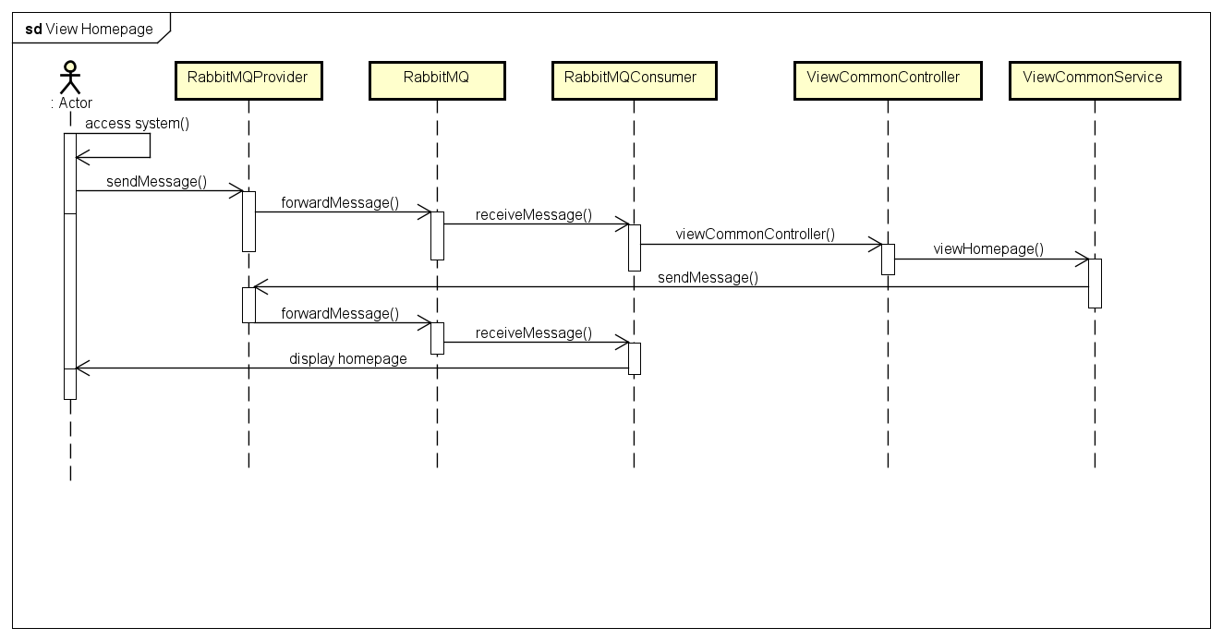

Figure 16. View Homepage sequence diagram.

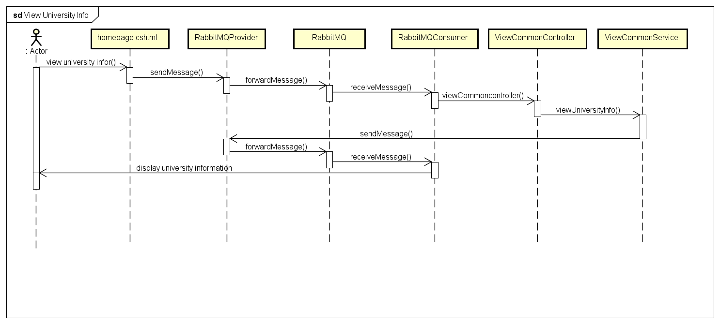

Figure 17. View University Information sequence diagram

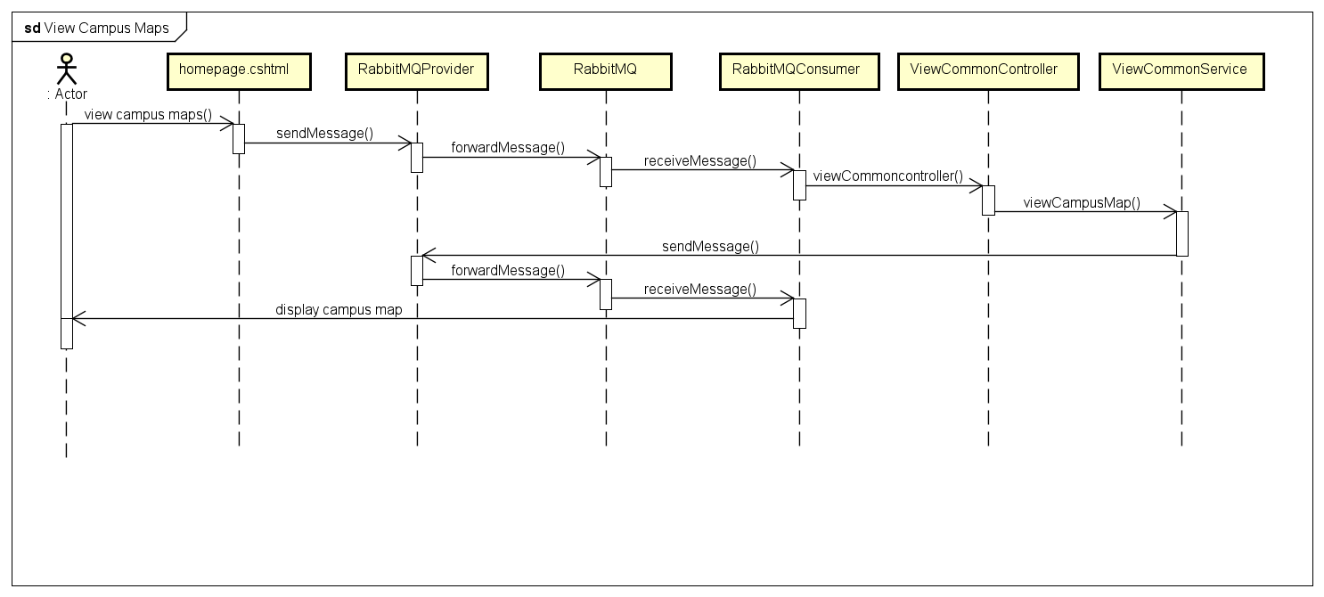

Figure 18. View Campus Map screen design.

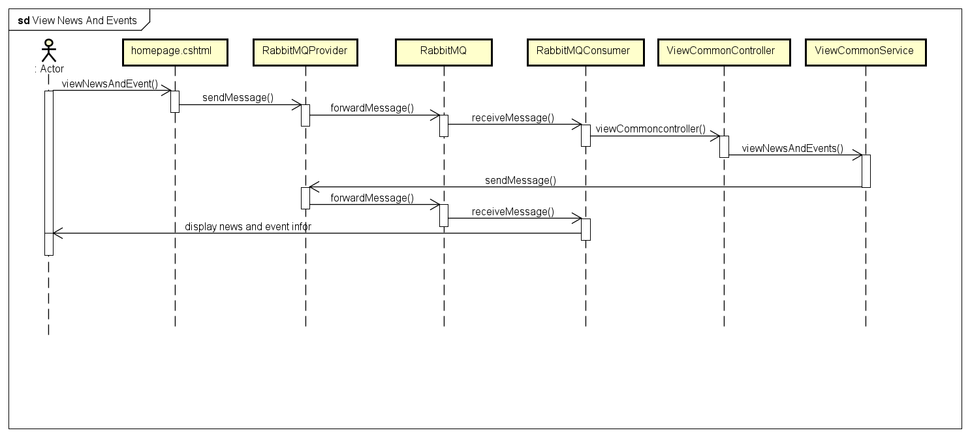

Figure 19. View News And Event screen design

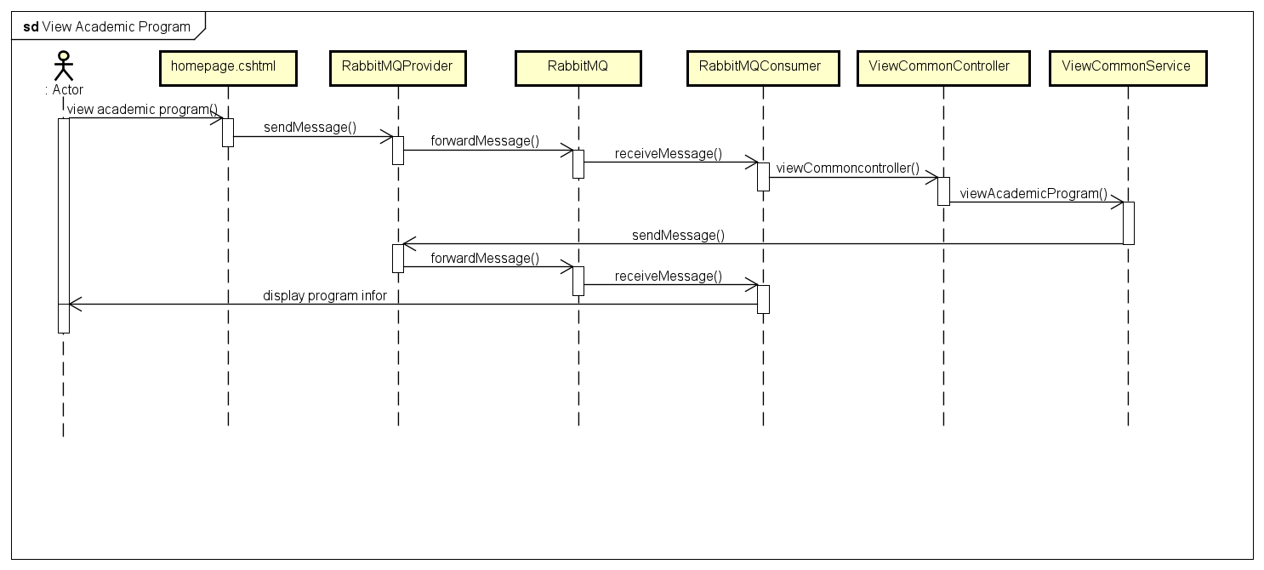

Figure 20. View Academic Program screen design

## 3.2. Account Management

### 3.2.1. Class Diagram

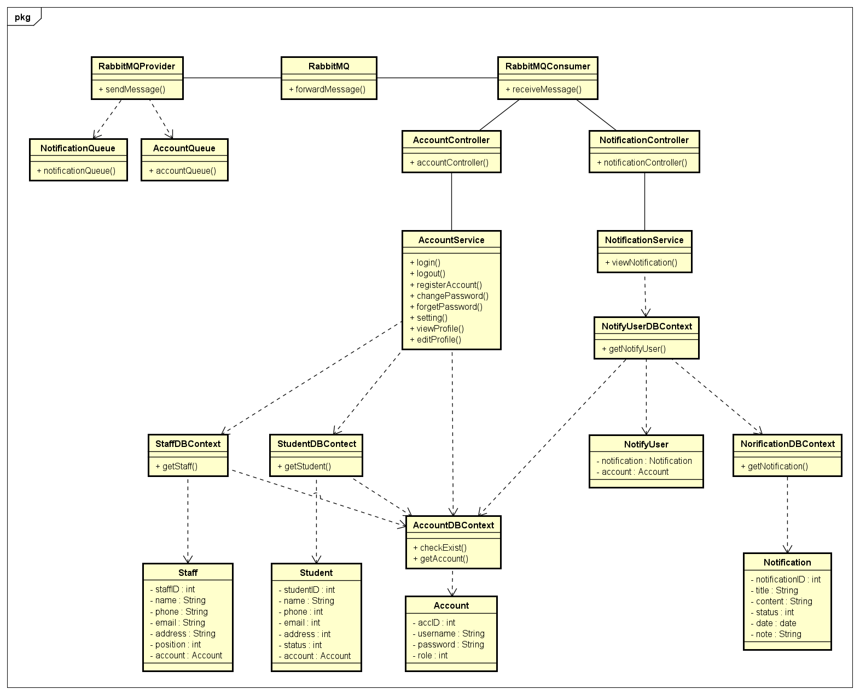

Figure 21. Account Management feature class diagram

### 3.2.3. Screen Design

Figure 22. Login screen design

Figure 23. Register Account screen design

Figure 24. Change Password screen design

Figure 25. Setting screen design

Figure 26. Edit Profile screen design.

Figure 27. View Profile screen design

### 3.2.4. Sequence Diagram

Figure 28. Login sequence diagram.

Figure 29. Logout sequence diagram.

Figure 30. View profile sequence diagram.

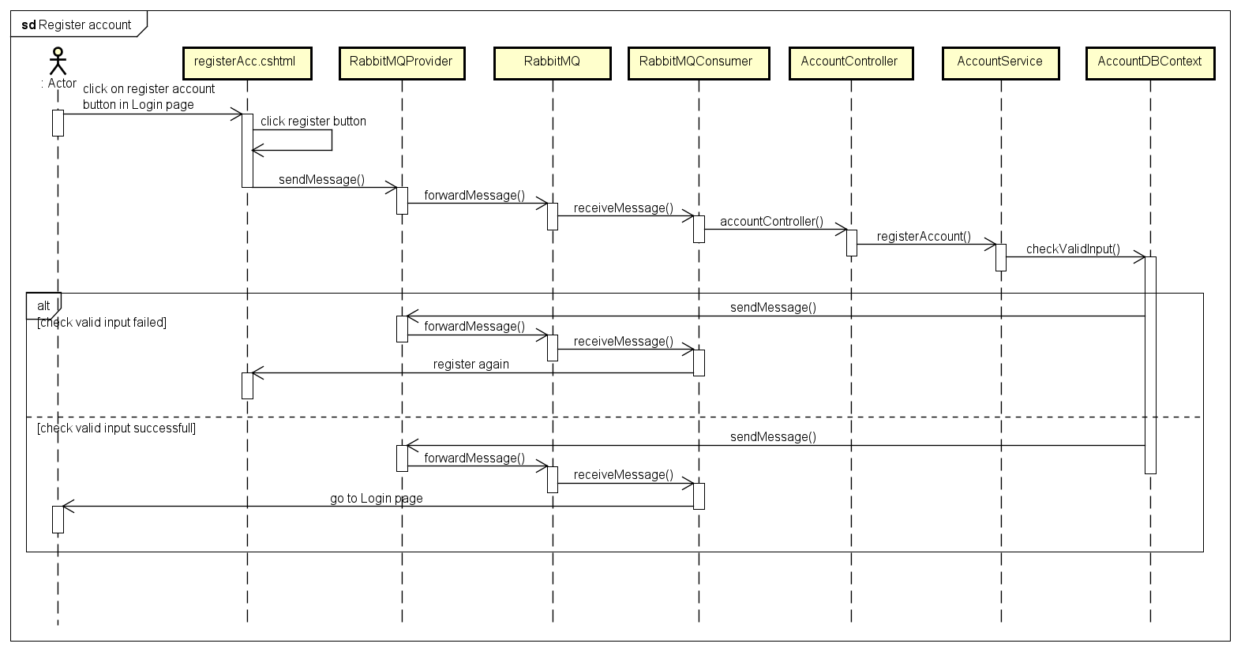

Figure 31. Register account sequence diagram.

Figure 32. Edit profile sequence diagram.

## 3.3. Admission Management

### 3.3.1. Class Diagram

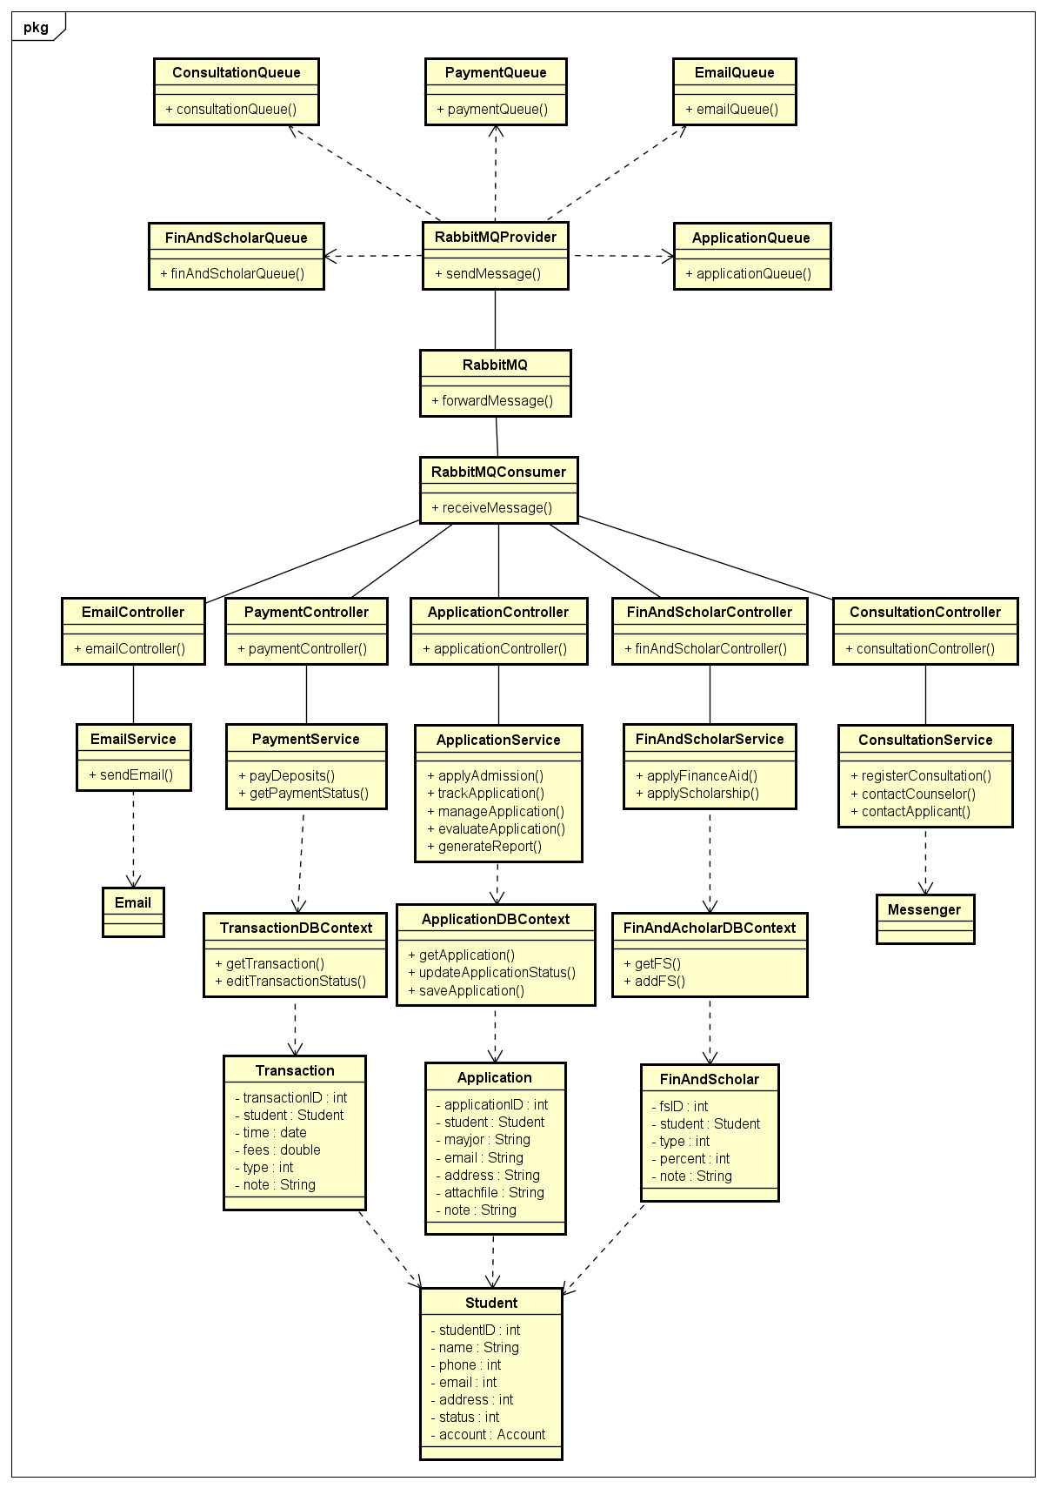

Figure 33. Admission feature class diagram.

### 3.3.3. Screen Design

Figure 34. Admission report screen design.

Figure 35. Manage Admission Even screen design.

Figure 36. Process deposits screen design.

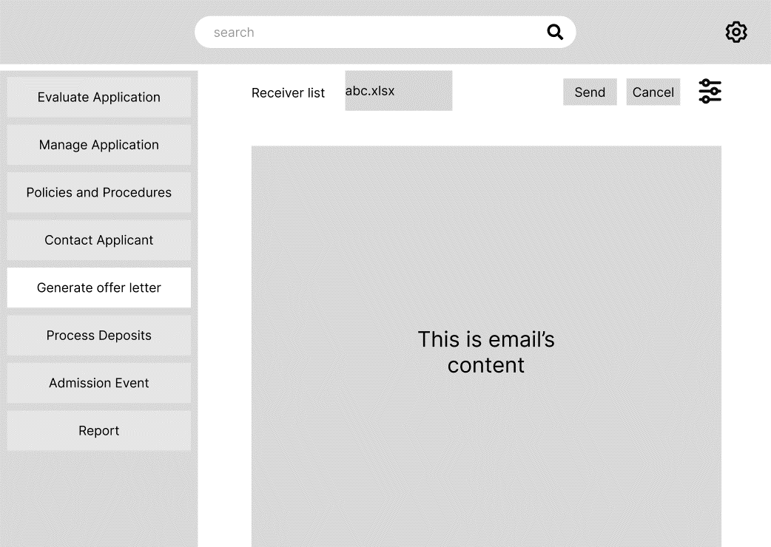

Figure 37. Generate offer letter screen design.

Figure 38. Contact Applicant screen design.

Figure 39. Manage Policies and Procedure screen design.

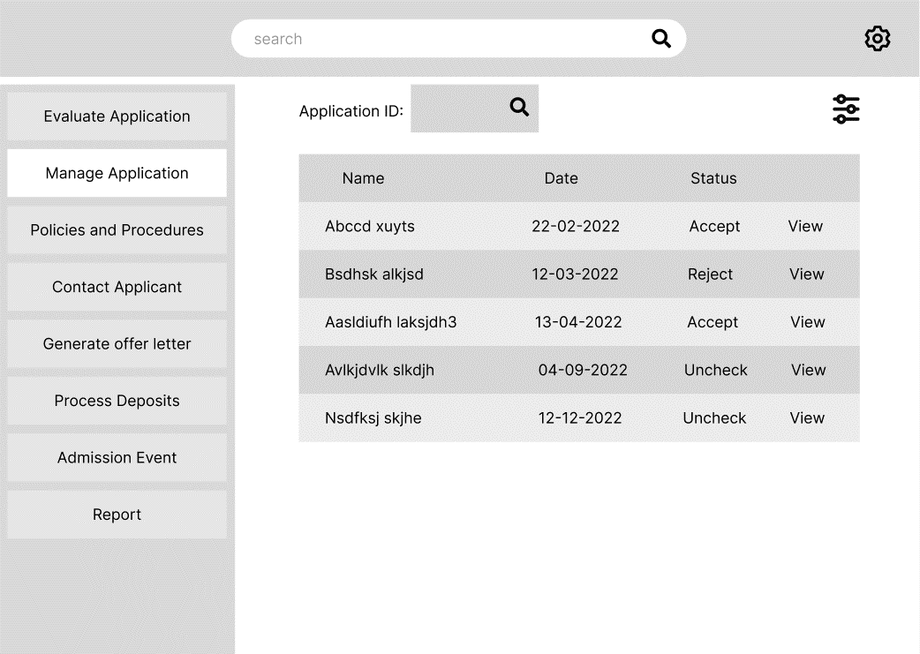

Figure 40. Manage Application screen design.

Figure 41. Evaluate Application screen design.

Figure 42. Apply Admission screen design.

### 3.3.4. Sequence Diagram

Figure 43. Apply Admission sequence diagram.

Figure 44. Track application sequence diagram.

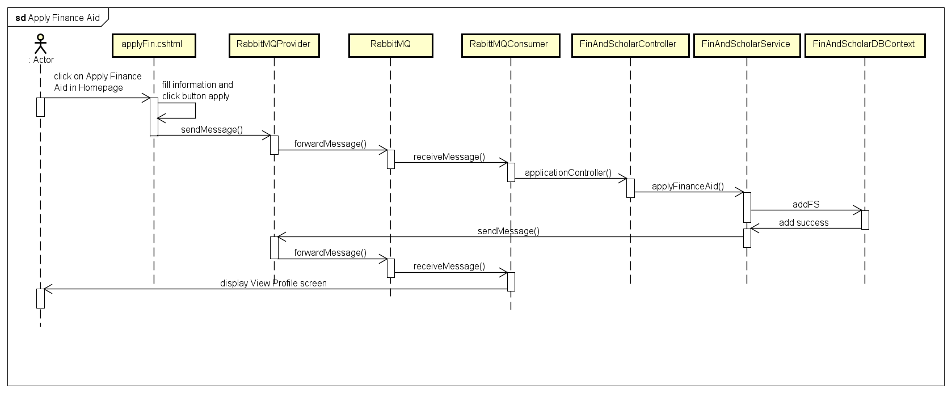

Figure 45. Apply Finance Aid sequence diagram.

Figure 46. Apply Scholarship sequence diagram.

## 3.4. Examination

### 3.4.1. Class Diagram

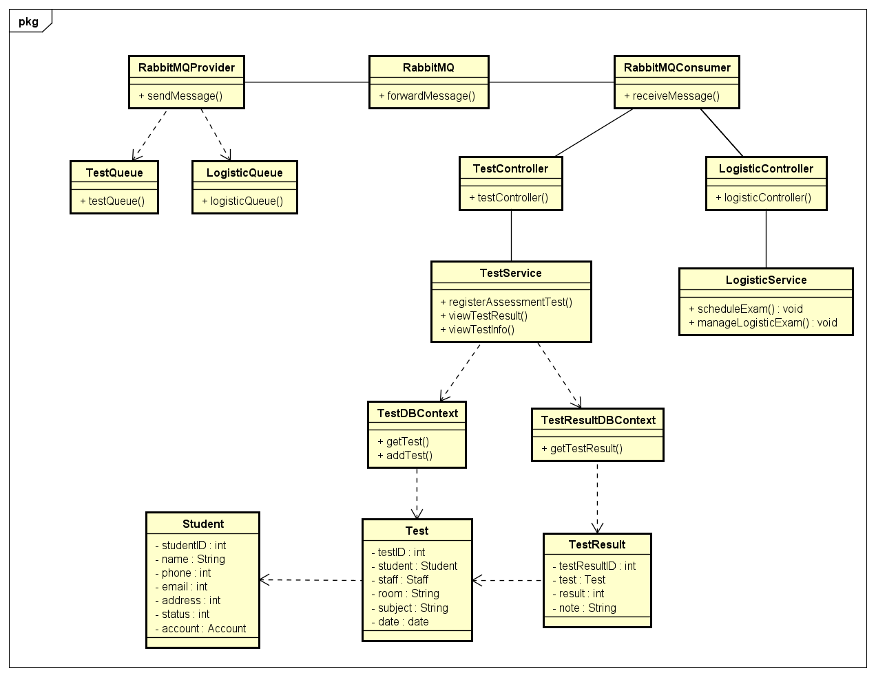

Figure 47. Examination feature class diagram.

### 3.4.3. Screen Design

Figure 48. Logistic Examination screen design.

Figure 49. Exam Schedule screen design.

Figure 50. Exam Result screen design.

Figure 51. Monitor Exam Performance screen design.

### 3.4.4. Sequence Diagram

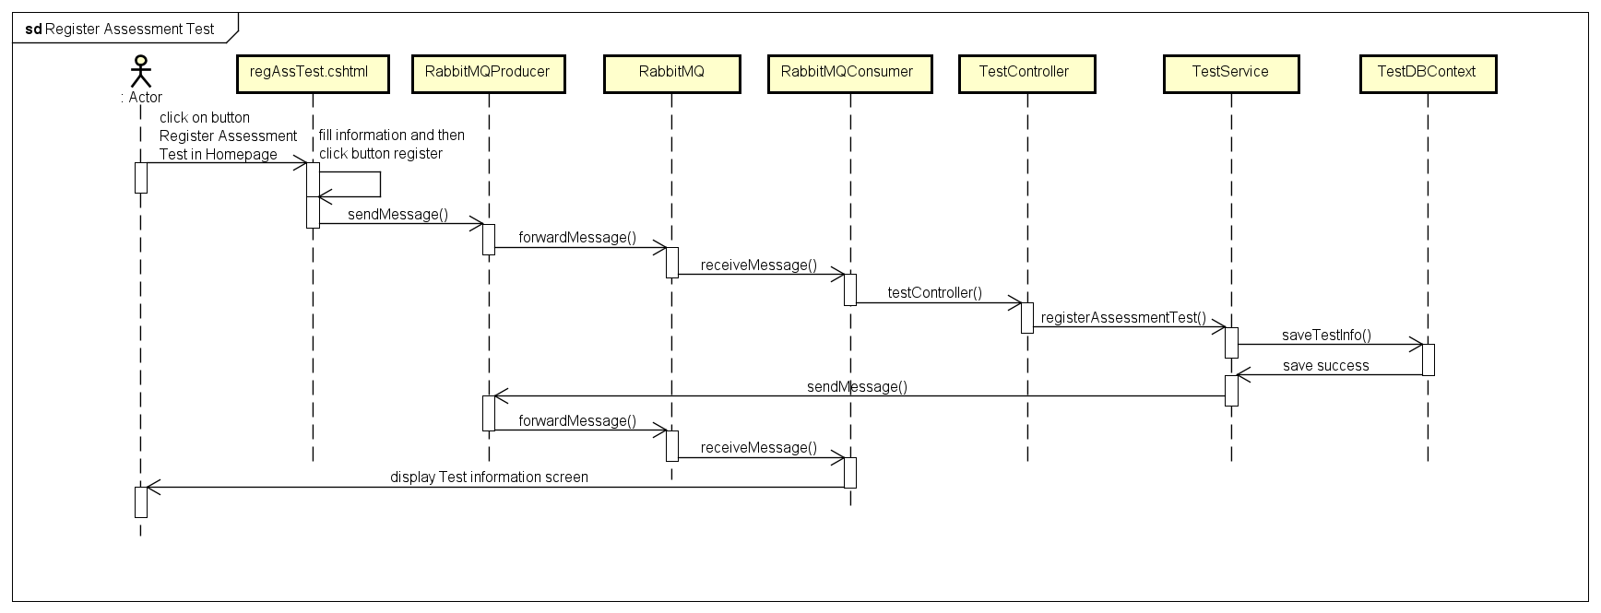

Figure 52. Register Assessment Test sequence diagram.

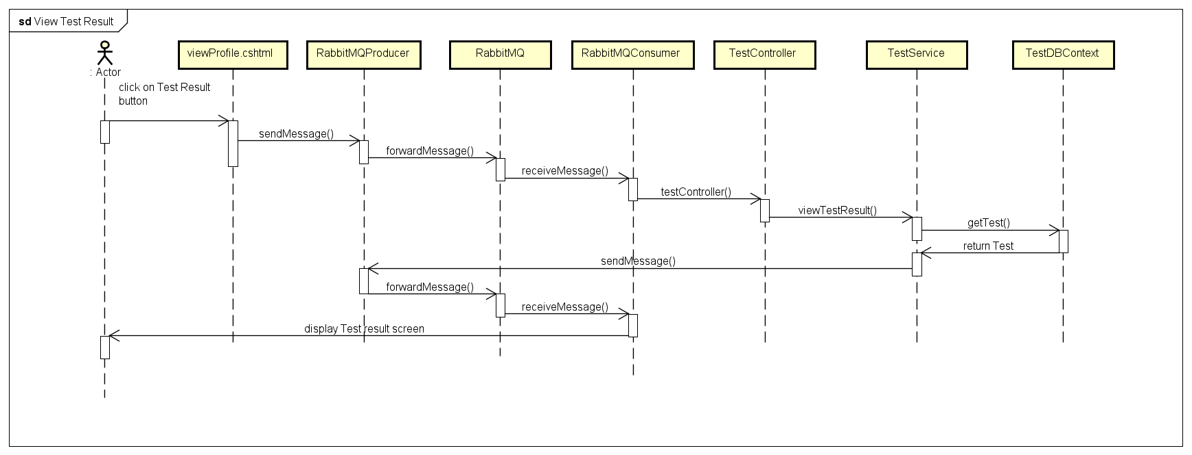

Figure 53. View Test Result sequence diagram.

Figure 54. View Test Information sequence diagram.

## 3.5. Marketing

### 3.5.1. Class Diagram

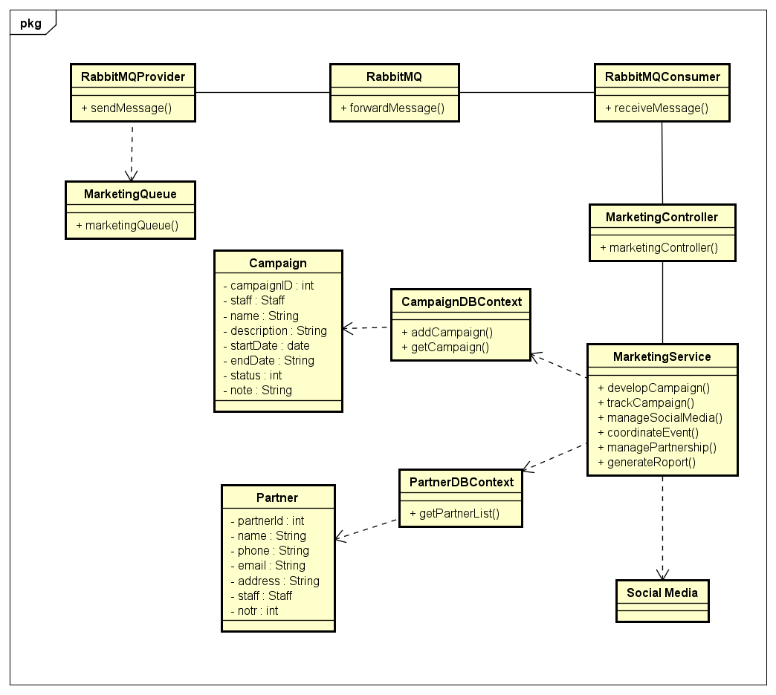

Figure 55. Marketing feature class diagram.

### 3.5.3. Screen Design

Figure 56. Manage Partnership screen design.

Figure 57. Generate Marketing Report screen design.

Figure 58. Segment Prospective Student screen design.

Figure 59. Track Campaign screen design.

Figure 60. Develop Campaign screen design.

Figure 61. Coordinate Event screen design.

Figure 62. Manage Social Media screen design.

### 3.5.4. Sequence Diagram

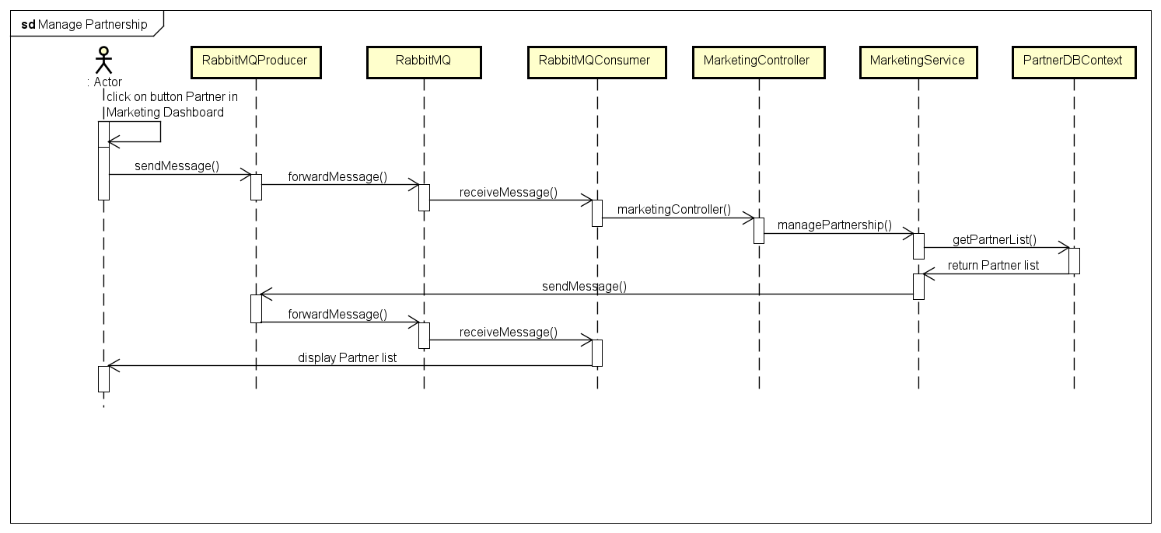

Figure 63. Manage Partnership sequence diagram.

## 3.6. Admin Management

### 3.6.1. Class Diagram

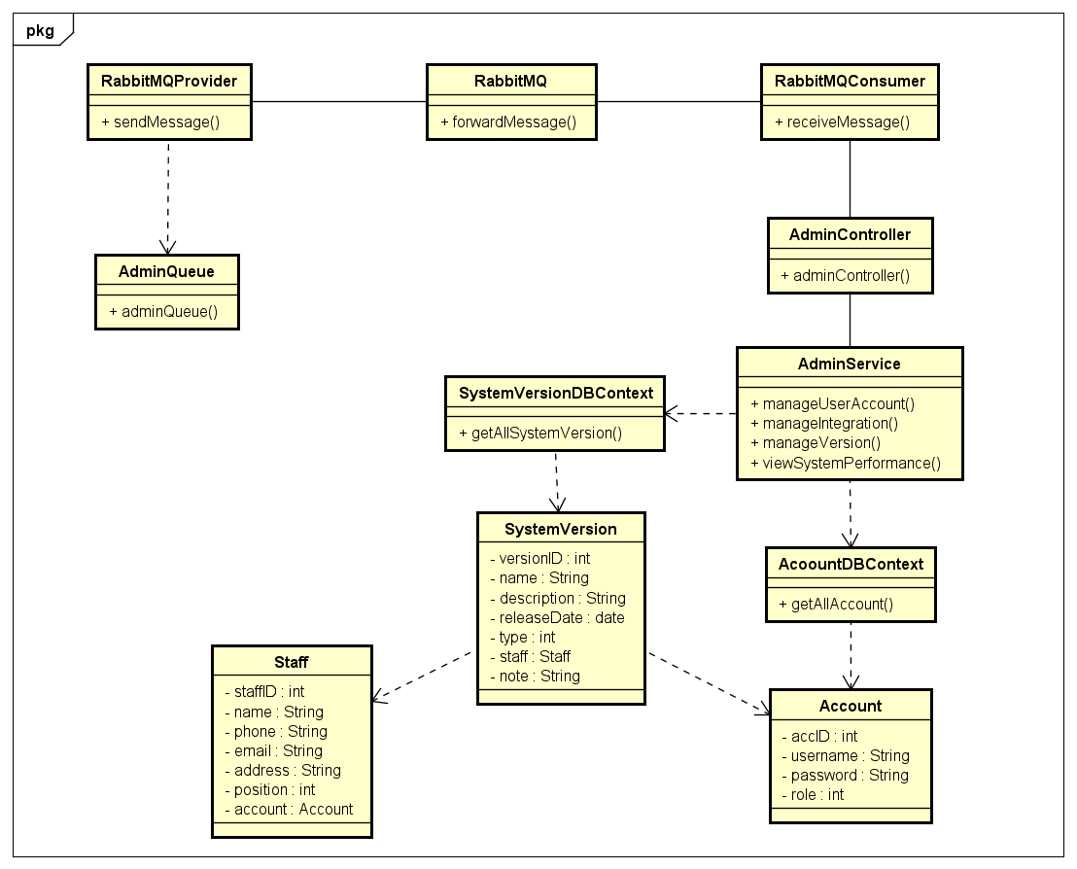

Figure 64.Admin Management feature class diagram.

### 3.6.3. Screen Design

Figure 65. Manage Integration screen design.

Figure 66. Monitor System Performance screen design.

Figure 67. Manage Updates and Upgrades screen design.

Figure 68. Manage User Account screen design.

### 3.6.4. Sequence Diagram

Figure 69. Manage Account sequence diagram.